Join us for an interactive simulation on tonometry!

Tonometry measures intraocular pressure (the pressure inside of the eye) in millimeters of mercury using an instrument called a tonometer. In this simulation, you will see and have a chance to perform the basic steps of Goldmann applanation tonometry.

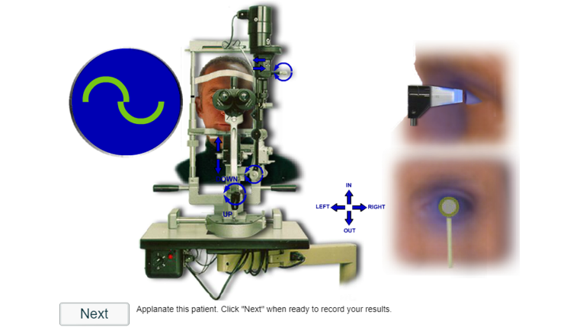

The simulation will be held using the online video communications platform, Zoom.

Instructions to Test Your Audio/Video on Zoom

You can join a test Zoom meeting to familiarize yourself with the Zoom and test your microphone/speakers before joining a Zoom meeting. You can also test your video or audio while in a Zoom meeting.

- Visit http://zoom.us/test.

- Click the blue Join button to launch Zoom.
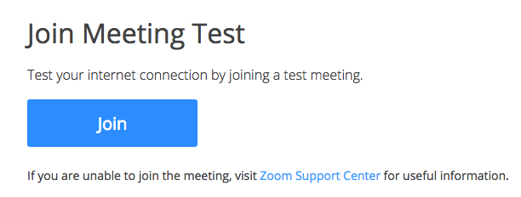

- When prompted by your browser, click Open Zoom Meetings. If you don't have Zoom installed on your computer, follow the prompts to download and install Zoom.

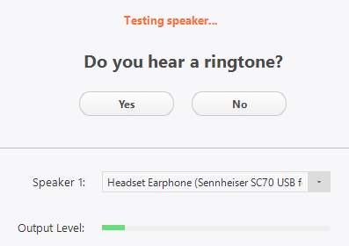
- The test meeting will display a pop-up window to test your speakers. If you don't hear the ringtone, use the drop-down menu or click No to switch speakers until you hear the ringtone. Click Yes to continue to the microphone test.
- If you don't hear an audio reply, use the drop-down menu or click No to switch microphones until you hear the replay. Click Yes when you hear the replay.
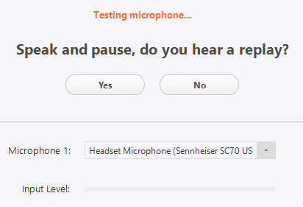

- Click Join with Computer Audio.
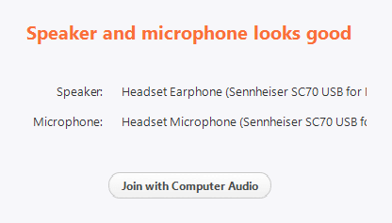

- Click Join with Computer Audio to join the test meeting with the selected microphone and speakers.
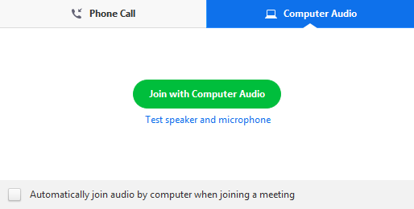
- You will join the test meeting as an attendee. Learn more about Attendee Controls in a Meeting.

